### **Step 1 : Create a apt Cookbook**

# cd /home/ubuntu/chef-repo

# knife cookbook create apt

**Step 9: Write recipe for package database update**

# vim /home/ubuntu/chef-repo/cookbooks/apt/recipes/default.rb

execute "apt-get update" do

command "apt-get update"

end

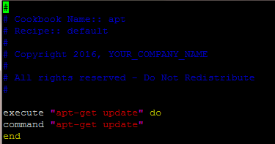

**Note :** A **execute** resource block typically executes a single command that is unique to the environment in which a recipe will run. Some **execute** resource commands are run by themselves, but often they are run in combination with other Chef resources. For example, a single command that is run by itself: